**Test Case 1: Storage Integration**

**Input:**

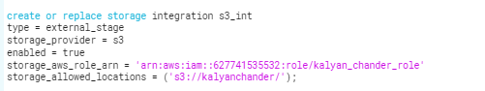



**Expected output:**

Using storage integration, the expected result to get **External storage id** and **IAM User ARN** to build a connection between AWS and snowflake.

**Actual Output:**

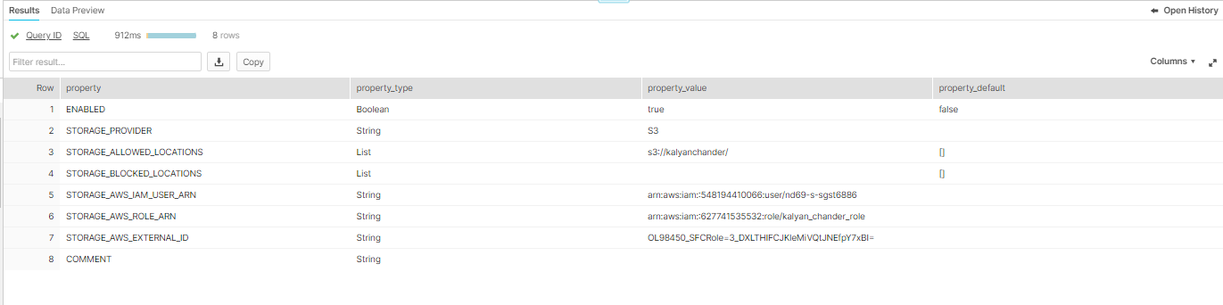

**Test Case 2: Load data from External stage**

**Input:**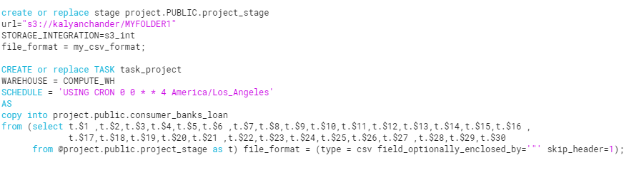

**Expected output:**

Loaded the data from external stage to table

**Actual Output:**

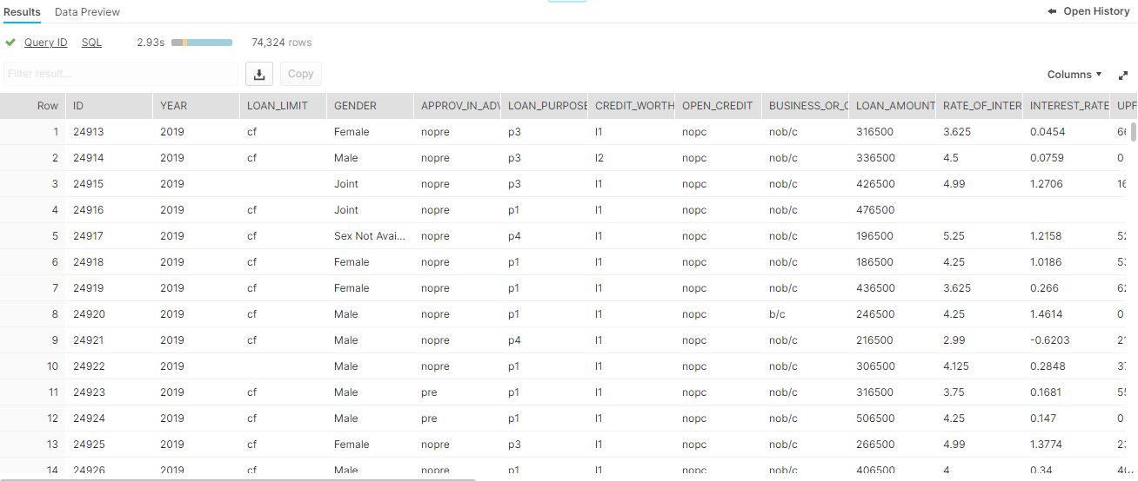

**Test Case 3: Slowly changing dimensions Type-2**

**Input:**

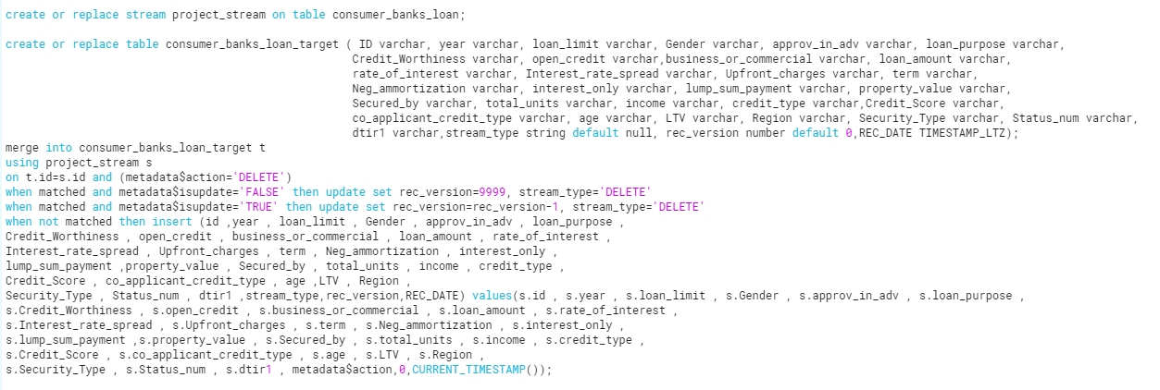

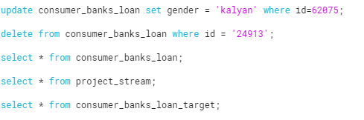

**Expected Output:**

We have perform SCD2 on source table by using stream.

**Actual Output:**

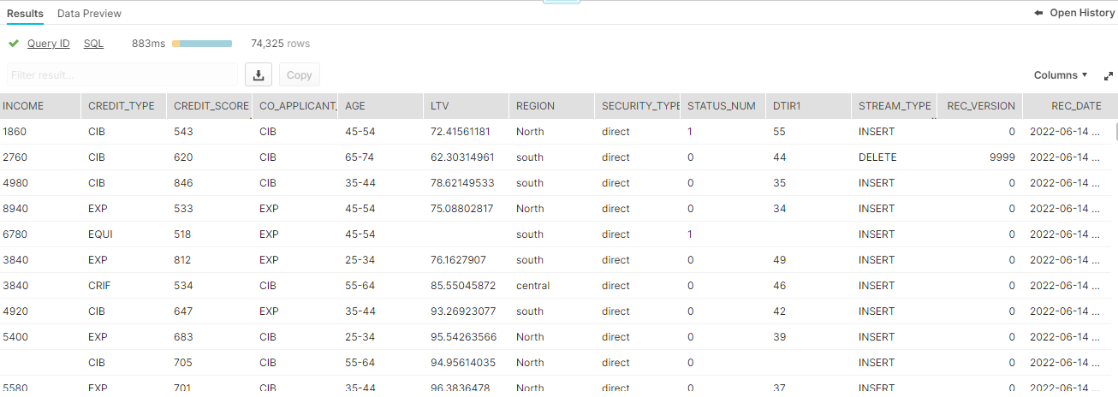

**Test Case 4: Analyze data (Using SQL Query)**

**Case1:**

**Input:**



**Expected output:**

The total loan amount for gender = 'female' and loan limit='cf'.

**Actual output:**

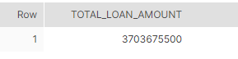

**Case 2:**

**Input:**

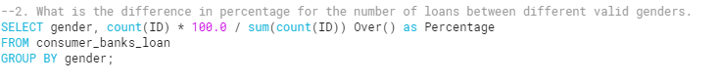

**Expected output:**

The difference in percentage for the number of loans between different valid genders.

**Actual Output:**

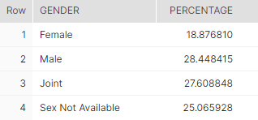

**Case 3:**

**Input:**



**Expected output:**

The difference in percentage of approval in advance between business and commercial loan.

**Actual Output:**

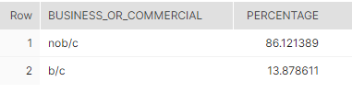

**Case 4:**

**Input:**



**Expected output:**

Here are 279 lumpsum pay for business loan.

**Actual output:**

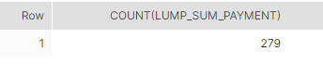

**Case 5:**

**Input:**



**Expected output:**

Average credit score for various age groups

**Actual Output:**

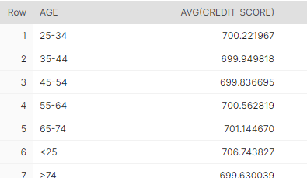

**Test Case 5: Column level Security**

**Input:**

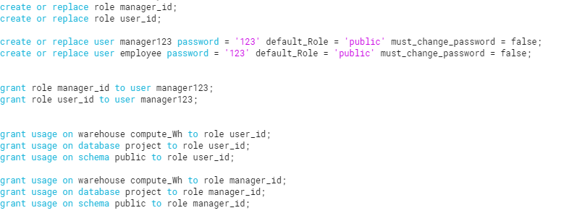

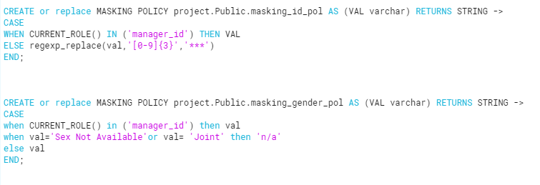

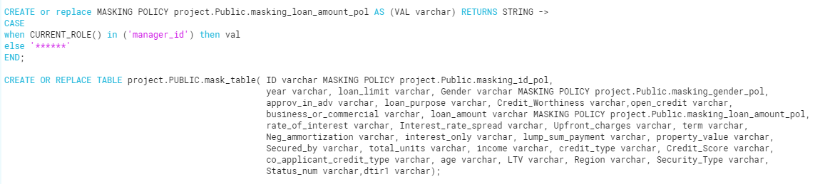

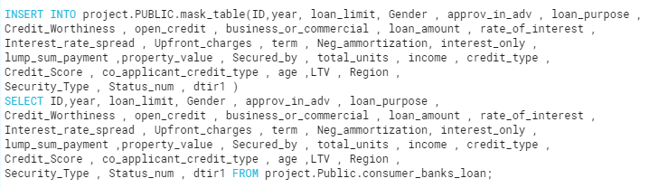

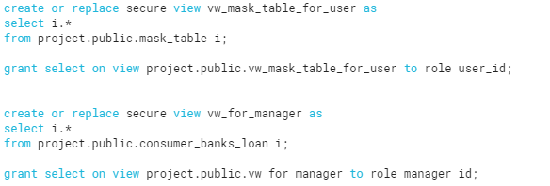

**Expected Output:**

We have to perform column level security by using masking policy on 3 columns i.e., ID, Gender, Loan amount.

Apart from the manager role if some other user roles try to see the data it will show them masked data.

**Actual Output:**



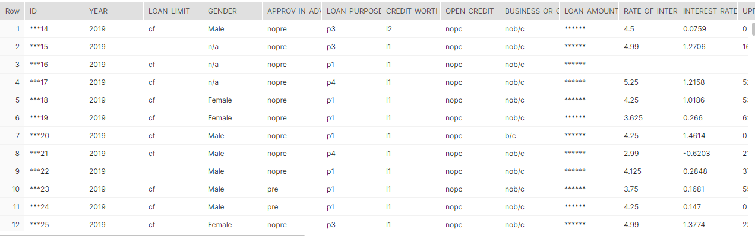



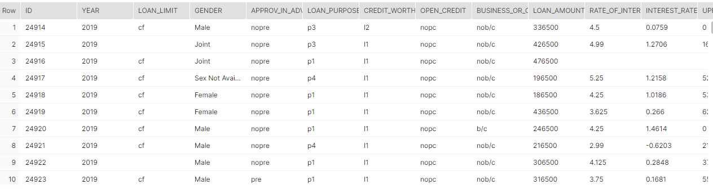

**Test Case 6: CSV File Converted into JSON format using python**

**Input:**

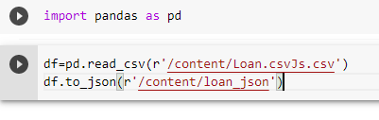

**Expected output:**

We have to convert csv file into JSON by using python.

**Actual Output:**

